Problem 4:

1. What is the emissions per capita of Canada?

Ans: 17.72

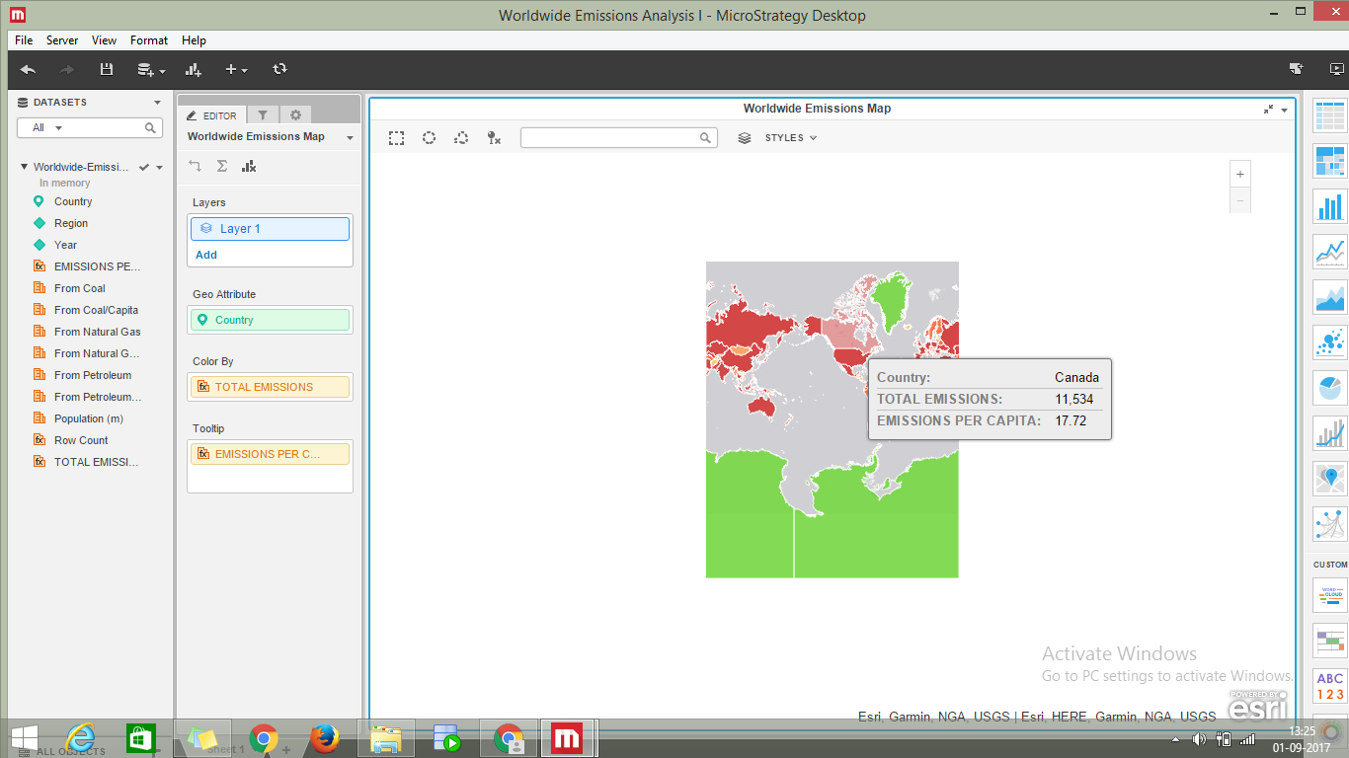

2. What is the overall trend in worldwide emissions?

Ans: The overall emissions are increasing at the end.

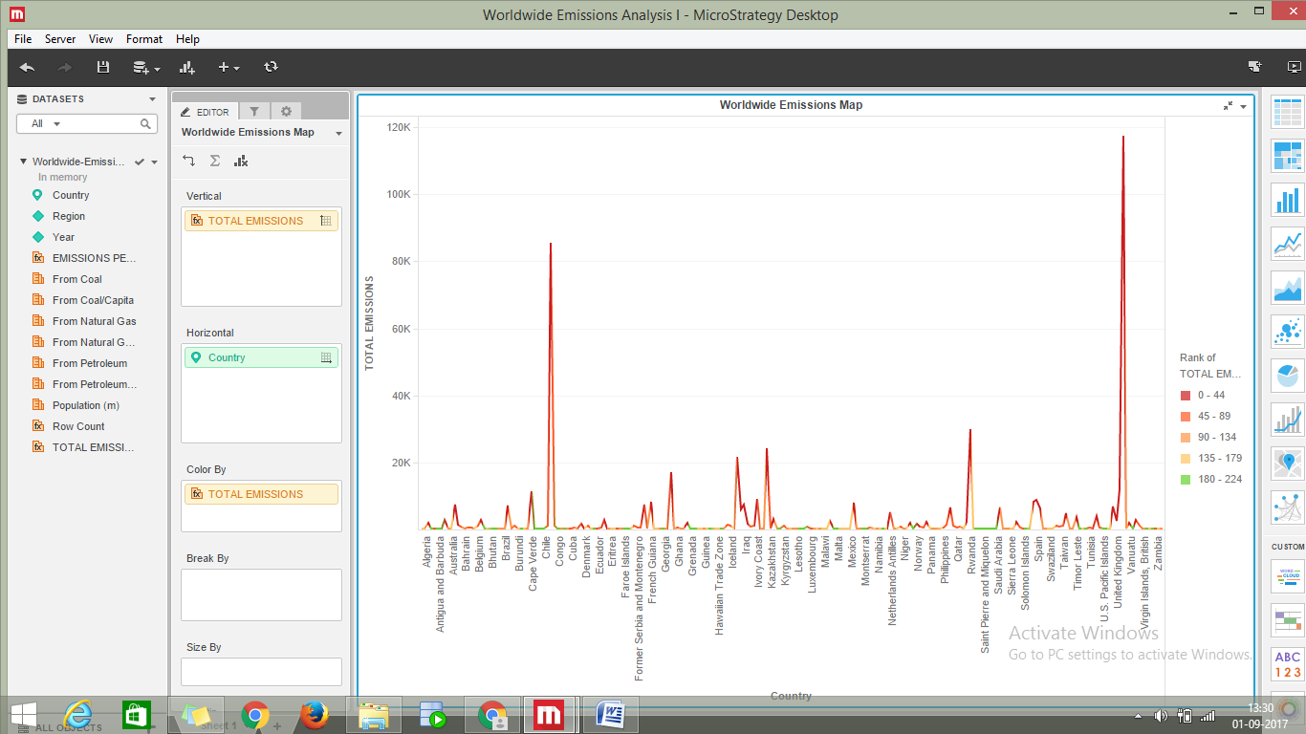

3. Notice that overall emissions declined in 2009, the only year in the total number of years surveyed that indicates emissions decreases in all three emissions sources. Why is that? What broader socio-political context might explain this single yearly decrease?

Ans: the overall emissions fell in 2009 due to the change from use of coal to natural gas as price of natural gas declined.

